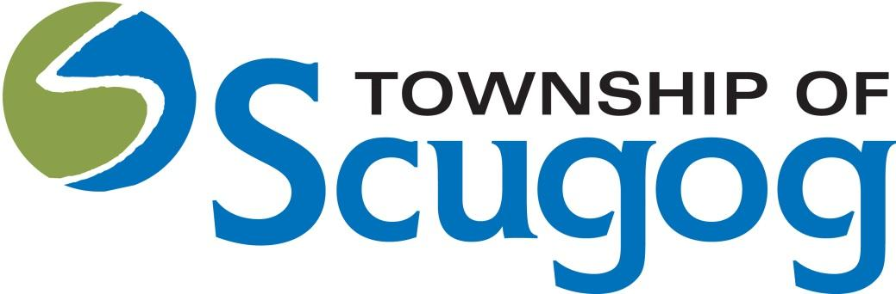

Scugog Accessibility, Diversity, Inclusion, Equity Advisory Committee
2023 - Annual Report and 2024 - Work Plan

A Message from the Committee
The Scugog Accessibility, Diversity, Inclusion, Equity Advisory Committee (SADIE) stands as a beacon of progress and empowerment in our Scugog community.

At the heart of SADIE’s mission is the desire to create a community where everyone, regardless of their background or abilities, feels valued and included. Our committee members are continually exposed to diverse perspectives and experiences, enriching their understanding of the world. This exposure is not only educational but also deeply personal, promoting empathy and emotional intelligence. SADIE provides a platform for members to connect with like-minded individuals and organizations. These connections can lead to collaborative projects, professional growth opportunities, and stronger community ties. Members have the unique opportunity to influence local policies and initiatives. This means directly impacting how our community addresses issues related to accessibility, diversity, inclusion, and equity. Being a part of the Scugog Accessibility, Diversity, Inclusion, Equity Advisory Committee is an enriching experience. It's more than a commitment; it's a journey towards a more inclusive and equitable future.

- Patricia Thomas, Chair
Corporate Services – SADIE Advisory Committee
Purpose /Mandate
The Township of Scugog Accessibility, Diversity, Inclusion, and Equity Advisory Committee (SADIE) advises Council on the elimination of barriers for the diverse population of our community. The committee will work actively to formulate and recommend opportunities to enhance community relations, pursue greater diversity and inclusion and investing in a culture of equity.

The Scugog Accessibility, Diversity, Inclusion and Equity Advisory Committee (SADIE) will assist staff with recommendations, advice, feedback, and information to the Township of Scugog on matters relating to diversity, equity, and inclusion by focusing on:
• Improving our understanding of diversity and commitment to inclusion
• Reinforcing diversity and inclusion within the organizational culture
• Engaging staff in diversity and inclusion efforts and promoting opportunities for leadership, advancement and employee development
• Identifying and addressing barriers to inclusion in the delivery of municipal programs and services
Under the Accessibility for Ontarians with Disabilities Act, 2005 (AODA), Section 29 of the AODA describes three (3) main activities in relation to accessibility:
1. Advise the Township of Scugog Council about the requirements and implementation of accessibility standards and the preparation of accessibility reports and other matters for which the council may seek its advice;
2. Review site plans and drawings described in section 41 of the Planning Act that the committee selects; and
3. Perform all other functions that are specified in the regulations.

Vision
Uphold a committee working relationship within our Membership, with Council, Township Staff and Regional AAC Groups;
Advocate for the importance of inclusion, diversity and accessibility within our organization while acting as a valuable resource, offer solutions or suggestions on how to strengthen our culture; and
Educate the community on the Accessible Customer Service Standards, Integrated Accessibility Standards Regulation and Amendments to Ontario Building Code.

2023 – SADIE Advisory Committee Annual Report
Project/goal/initiative | Status/next steps
Participated in the Pet Valu Dog Guides Walk to champion and fundraise for service animals | Completed
Supported and approved the AODA Multi-Year Accessibility Plan | Completed
Treat Accessibility - Halloween | Investigated and attempted to roll out the Treat Accessibility, had difficulty getting supplies etc. Moved to 2024
Consulted on development applications for the playground and LSEP accessibility | Completed
Conducted preliminary investigation of mobility device charging stations and potential funding options | Completed
Consultation on the Palmer Park Splash Pad accessibility | Completed

2023 Budget
Council Approved Budget | Funds Spent | Funds Remaining | Explanation
$2,000 | $0 | $0 | The election year prevented the committee from implementing projects and initiatives within the timeframe given.

2024 SADIE Advisory Committee - Work Plan
Projects/Goals/Initiatives | Timeline | Estimated Cost
Pursue & champion the Treat - Accessibility campaign for Halloween by facilitating distribution of signage and education materials at municipal locations | September 2024 reach out to campaign advisor (Chair & Christy) - to October 31 2024 | Potential shipping cost $100
Host & participate in outreach and education events within the community including potential guest speaker series | 2024 | Event supplies $1900
Investigate and work with the township staff on generating opportunities to apply for grants | 2024 | n/a
Participate in the Tri-AAC meeting to align with the neighboring AAC Committee’s and collaborate with Regional partners on accessibility & inclusion initiatives | 2024 | n/a
Preliminary Committee Budget Request to Staff
$2,000.00 | November 2023
Final Council approved Budget Amount | Date TBD

